Report On

Student Admission Council

Submitted in partial fulfillment of the requirements of the Course project in Semester III of Second Year Computer Engineering

by

Shashank Bhatt (Roll No.02) Vivek Rathod (Roll No.19) Vedant Patil (Roll No.11) Aadi Raut (Roll No.21)

Supervisor

Prof. Akshaya Prabhu



## University of Mumbai Vidyavardhini's College of Engineering & Technology

**Department of Computer Engineering**

**(2023-24)**

# Vidyavardhini's College of Engineering & Technology Department of Computer Engineering

**CERTIFICATE**

This is to certify that the project entitled “Student Admission Council” is a bonafide work of Shashank Bhatt (Roll No.02), Vivek Rathod (Roll No.19), Vedant Patil (Roll No. 11), Aadi Raut (Roll No. 21) submitted to the University of Mumbai in partial fulfillment of the requirement for the Course project in semester III of Second Year Computer Engineering.

**Supervisor**

Prof. Akshaya prabhu

Internal Examiner External Examiner

Dr Megha Trivedi Head of Department

Dr. H.V. Vankudre Principal

# Contents

## Pg. No

|  |  |
| --- | --- |
| 1 Abstract | 01 |
| 2 Problem Statement | 02 |
| 3 Block Diagram | 03 |
| 4 Module Description | 04 |
| 5 Brief description of software used and its program | 05 |
| 6 Code | 06 |
| 7 Results | 11 |
| 8 Conclusion | 12 |
| 9 References | 13 |
| 10 Plagiarism Report | 14 |

**Abstract**

The JEE and MHTCET Counseling Admissions Process System developed an advanced software application designed to automate and streamline the admission counseling process for candidates appearing for Joint Entrance Examination (JEE) and Maharashtra Common Entrance Test (MHTCET). The system aims to provide a user-friendly interface for students, counselors, and administrators, facilitating a seamless and efficient admissions process. Furthermore, the system streamlines the entire admissions process, from initial application to final seat allotment, ensuring that it is efficient and effective, saving time for both students and administrative staff. Importantly, the software is highly customizable, making it adaptable to changing guidelines and policies. Role-based access control is incorporated into the application, offering different levels of access and control to students, counselors, and administrators, which enhances security and ensures that users only access relevant information. A communication platform is integrated, allowing for efficient communication between students and counselors, including notifications, updates, and the ability to seek assistance or ask questions. In summary, the "JEE and MHTCET Counseling Admissions Process System" is a comprehensive software solution that brings automation, efficiency, and user-friendliness to the admission counseling process for students participating in JEE and MHTCET. It caters to the various stakeholders, streamlines the entire process, enhances data management, security, and communication, ultimately making the admission process more accessible and efficient for all parties involved.

## Problem statement

The website of the Student Admission Council is currently encountering several issues that are adversely affecting the user experience. These issues include inefficient search functionality, disorganized college reviews spanning across three separate pages, and a complex access system for cutoff lists pertaining to different colleges and departments. To optimize and enhance the user experience, it is imperative to address these challenges by implementing solutions that will lead to improved search accuracy, streamlined access to college reviews, and simplified access to essential cutoff information.

## Block Diagram

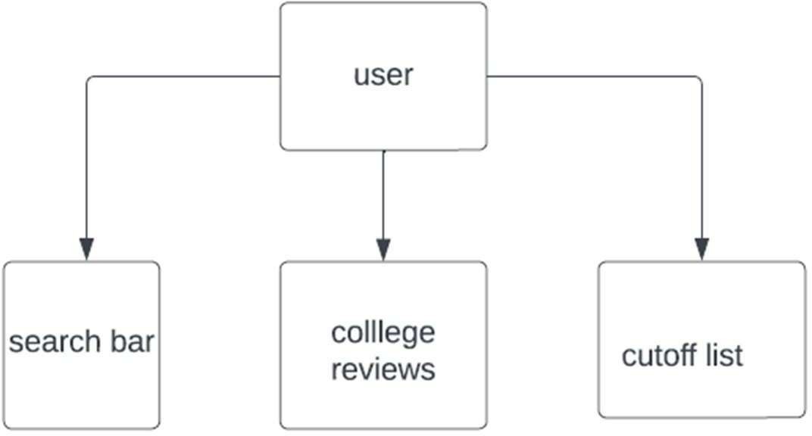

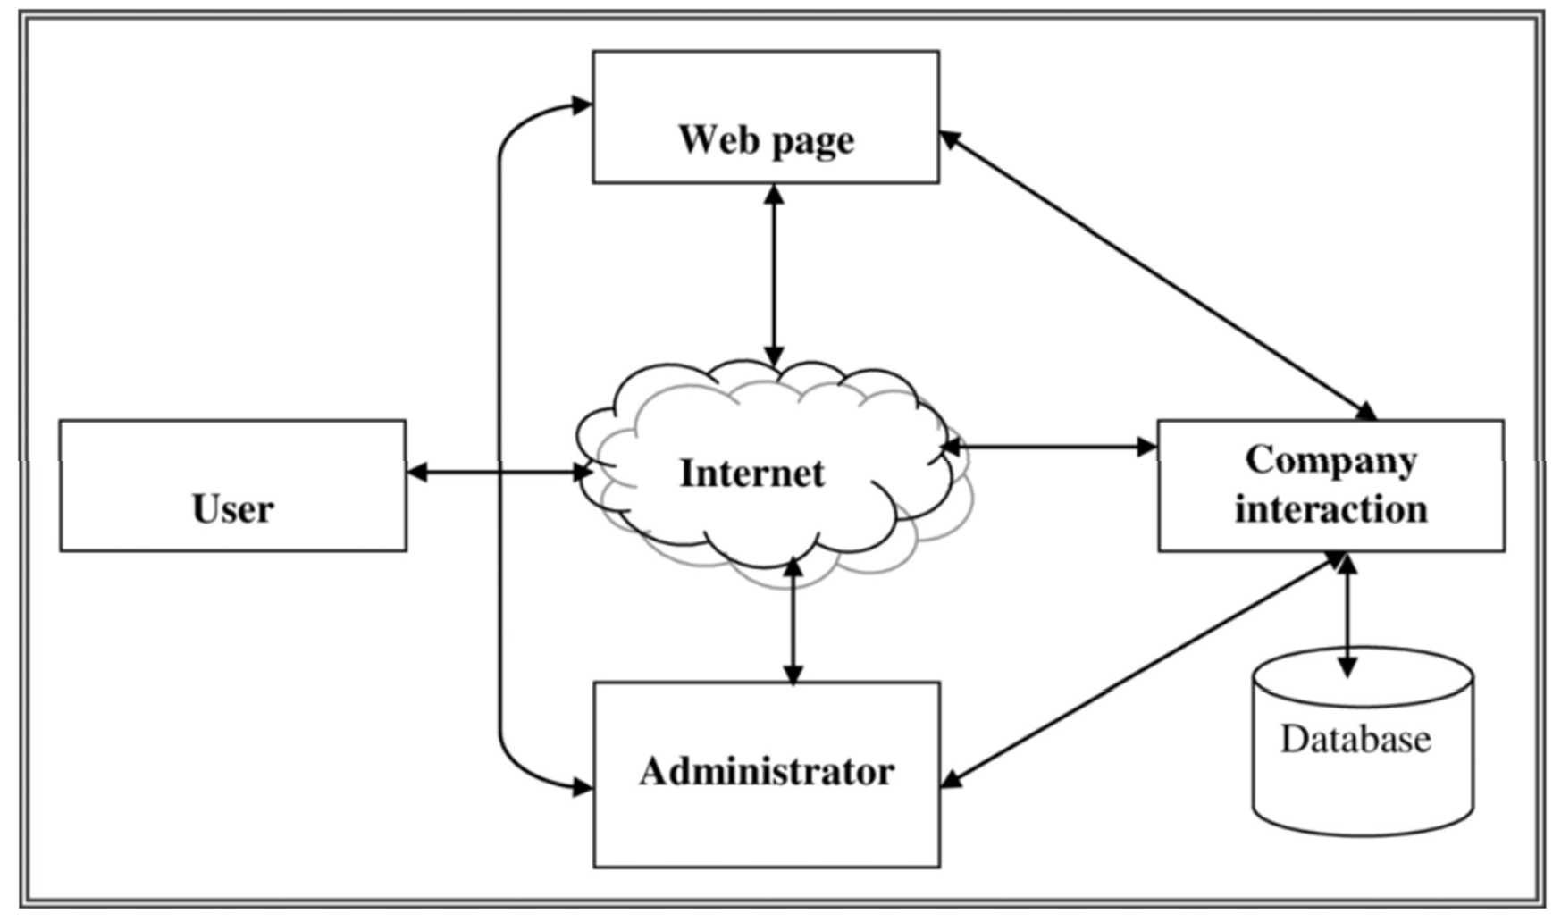

**Module Description**

Student Admission Council Website

The Student Admission Council website is a comprehensive online platform designed to assist students and applicants in their college selection process, providing essential features and resources:

1. Search Bar:

* The website features a user-friendly search bar, allowing visitors to search for information about colleges, courses, or any specific details they're interested in. Users can enter keywords or criteria to access relevant information quickly.

1. Study Material:

* The website offers a dedicated section for study materials. Here, students can access a wide range of educational resources, including study guides, sample papers, and educational content related to their academic pursuits. This section supports their learning and preparation for admissions.

1. College Reviews:

* The College Reviews section is an invaluable resource for prospective students. It's structured across three pages and contains comprehensive and detailed insights into various colleges. Users can access reviews, ratings, and comments provided by current and former students, offering a firsthand look at the college experience.

1. Cutoff Lists:

* The Cutoff Lists section presents an organized collection of admission cutoff scores for multiple colleges and universities. Users can navigate through a list of institutions and departments to review the minimum scores required for admission. This information is crucial for applicants in making informed decisions about where to apply.

The Student Admission Council website is dedicated to streamlining the college selection process and supporting the academic endeavors of students. It serves as a valuable resource for research, preparation, and decision-making, ultimately assisting individuals in achieving their educational goals.

## Brief description of software used and its programming

* Frontend Development:

1. HTML (HyperText Markup Language): HTML is the core markup language used for creating the structure and content of web pages. In your website, HTML is employed to define the layout, headings, paragraphs, links, forms, and other elements necessary for presenting information to users.
2. CSS (Cascading Style Sheets): CSS is used to enhance the visual presentation of your website. It styles the HTML elements by specifying attributes like colors, fonts, margins, and padding. It's crucial for ensuring a visually appealing and consistent design.

* Backend Development:

1. JavaScript: JavaScript is a versatile scripting language used for the website's backend. It plays several critical roles, including:
   1. Data Storage: JavaScript enables you to store and manage information about colleges, reviews, and cutoff lists.
   2. Interactivity: JavaScript allows for dynamic interactions on the website, such as handling user input, responding to search queries, and loading content on demand
   3. Study Material Section: JavaScript can be used to create interactive features for the study material section, allowing users to browse and access

educational resources.

## Code

JAVASCRIPT

document.addEventListener("DOMContentLoaded", function () {

const collegeNameInput = document.getElementById("college-name-input"); const searchButton = document.getElementById("search-button");

const collegeInfo = document.getElementById("college-info"); const collegeList = document.getElementById("college-list");

const autocompleteSuggestions = document.getElementById("autocomplete- suggestions");

var linkElement = document.createElement("link");

// Set the attributes for the link element linkElement.rel = "stylesheet"; linkElement.type = "text/css";

linkElement.href = "datastore.css"; // Replace "styles.css" with the path to your CSS file

// Append the link element to the head of the document document.head.appendChild(linkElement);

// Sample data for colleges const colleges = []

// Create a list of college names for suggestions

const collegeNamesList = colleges.map(college => college.name);

collegeNameInput.addEventListener("input", function () { const input = collegeNameInput.value.trim().toLowerCase(); const suggestions = collegeNamesList.filter(name =>

name.toLowerCase().includes(input)); displaySuggestions(suggestions);

});

function displaySuggestions(suggestions) { autocompleteSuggestions.innerHTML = ""; suggestions.forEach(suggestion => {

const listItem = document.createElement("li"); listItem.textContent = suggestion; listItem.addEventListener("click", function () {

collegeNameInput.value = suggestion; autocompleteSuggestions.innerHTML = "";

});

autocompleteSuggestions.appendChild(listItem);

});

}

collegeNameInput.addEventListener("keyup", function(event) {

if (event.key === "Enter") { searchCollege(collegeNameInput.value.trim());

}

});

searchButton.addEventListener("click", function () { const collegeName = collegeNameInput.value.trim(); if (collegeName) {

searchCollege(collegeName);

}

});

collegeNameInput.addEventListener("input", function () { const collegeName = collegeNameInput.value.trim(); searchColleges(collegeName);

});

function searchColleges(query) {

const filteredColleges = colleges.filter(college => college.name.toLowerCase().includes(query.toLowerCase())

);

if (filteredColleges.length > 0) { displayCollegeList(filteredColleges); collegeInfo.innerHTML = "";

} else {

displayNotFoundMessage();

}

}

function displayCollegeList(colleges) { collegeList.innerHTML = ""; colleges.forEach(college => {

const listItem = document.createElement("li"); listItem.textContent = college.name; listItem.addEventListener("click", function () {

displayCollegeInfo(college);

});

collegeList.appendChild(listItem);

});

}

function searchCollege(name) {

const college = colleges.find(college => college.name.toLowerCase() === name.toLowerCase());

if (college) { displayCollegeInfo(college);

} else {

displayNotFoundMessage();

}

}

// Create a list of college names for suggestions

const collegeNamesList = colleges.map(college => college.name);

collegeNameInput.addEventListener("input", function () { const input = collegeNameInput.value.trim().toLowerCase(); const suggestions = collegeNamesList.filter(name =>

name.toLowerCase().includes(input)); displaySuggestions(suggestions);

});

function displaySuggestions(suggestions) { autocompleteSuggestions.innerHTML = ""; suggestions.forEach(suggestion => {

const listItem = document.createElement("li"); listItem.textContent = suggestion; listItem.addEventListener("click", function () {

collegeNameInput.value = suggestion; autocompleteSuggestions.innerHTML = "";

});

autocompleteSuggestions.appendChild(listItem);

});

}

collegeNameInput.addEventListener("keyup", function(event) { if (event.key === "Enter") {

searchCollege(collegeNameInput.value.trim());

}

});

searchButton.addEventListener("click", function () {

const collegeName = collegeNameInput.value.trim(); if (collegeName) {

searchCollege(collegeName);

}

});

collegeNameInput.addEventListener("input", function () { const collegeName = collegeNameInput.value.trim(); searchColleges(collegeName);

});

function searchColleges(query) {

const filteredColleges = colleges.filter(college => college.name.toLowerCase().includes(query.toLowerCase())

);

if (filteredColleges.length > 0) { displayCollegeList(filteredColleges); collegeInfo.innerHTML = "";

} else {

displayNotFoundMessage();

}

}

function displayCollegeList(colleges) { collegeList.innerHTML = ""; colleges.forEach(college => {

const listItem = document.createElement("li"); listItem.textContent = college.name; listItem.addEventListener("click", function () {

displayCollegeInfo(college);

});

collegeList.appendChild(listItem);

});

}

function searchCollege(name) {

const college = colleges.find(college => college.name.toLowerCase() === name.toLowerCase());

if (college) { displayCollegeInfo(college);

} else {

displayNotFoundMessage();

}

}

## Results

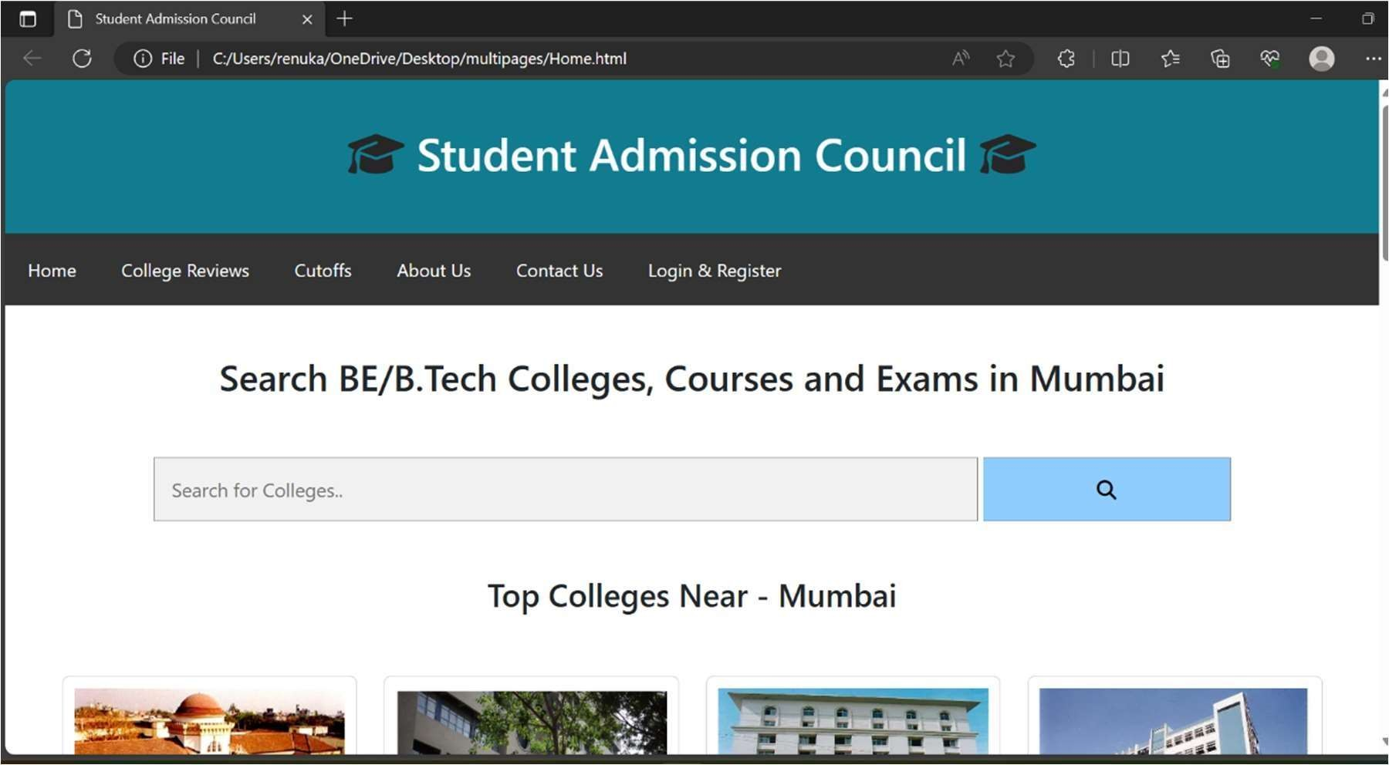

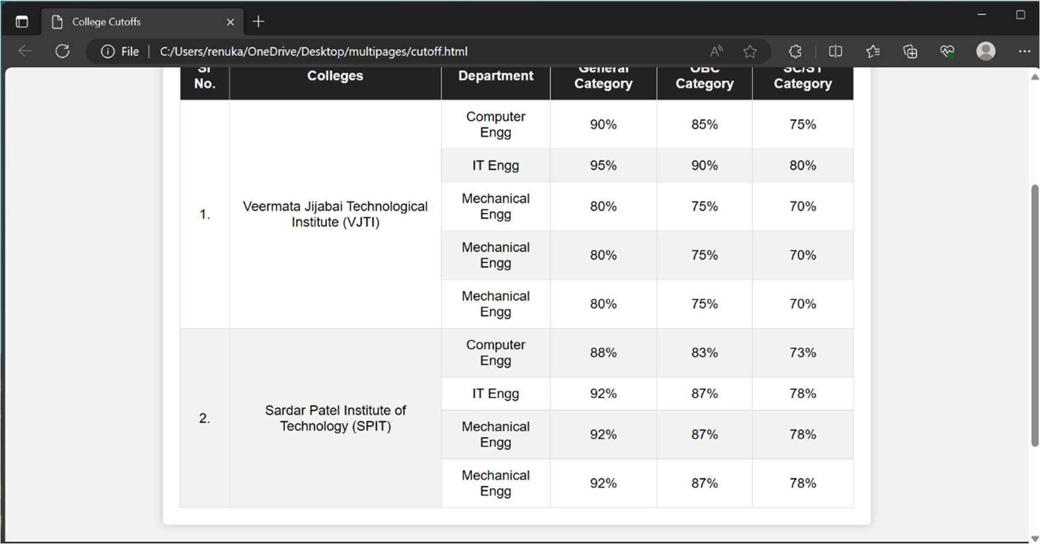

**Conclusion**

The JEE and MHTCET Counseling Admissions Process System is a powerful and efficient tool that simplifies the complex admission counseling process for students, counselors, and administrators alike. With its user-friendly interface, real-time updates, and comprehensive features, the system significantly reduces manual intervention, saves time, and ensures a transparent and fair allocation of seats. It plays a pivotal role in optimizing the admissions process, ultimately contributing to the smooth functioning of educational institutions and the academic growth of students.

## References

1. https://collegedunia.com/
2. https://getbootstrap.com/docs/5.0/components/card/
3. sssshttps://developer.mozilla.org/en- US/docs/Learn/Getting_started_with_the_web/JavaScript_basics
4. https://youtu.be/61ppyY5rUB0?si=7hexS0y7hOjgnmbU

**Plagiarism Report**

